|  |  |  |  |  |  |
| --- | --- | --- | --- | --- | --- |
| **Validation** | | | | | |
| Author | | **Controller** | | **Approver** | |
| Name | Date/Visa | **Name** | **Date/Visa** | **Name** | **Date/Visa** |
|  |  |  |  |  |  |

Document History

|  |  |  |
| --- | --- | --- |
| Version | Date | Version Details |
|  |  |  |
|  |  |  |
|  |  |  |
|  |  |  |
|  |  |  |

Participants

|  |  |  |  |  |
| --- | --- | --- | --- | --- |
| Company | Name | ID | Role | Present |
|  |  |  |  |  |
| ThoughtWorks | Rafael S Almeida |  | Solution Architect | Tech Leader | O |
|  |  |  |  |  |
|  |  |  |  |  |
|  |  |  |  |  |
|  |  |  |  |  |
|  |  |  |  |  |
|  |  |  |  |  |
|  |  |  |  |  |
|  |  |  |  |  |
|  |  |  |  |  |
|  |  |  |  |  |
|  |  |  |  |  |
|  |  |  |  |  |
|  |  |  |  |  |
|  |  |  |  |  |
|  |  |  |  |  |
|  |  |  |  |  |

1. Objective

The objective of this document to bring a vision about the architecture for this application TW-Merchant-Galaxy-Changelle and server as a reference to change in the future.

1. Introduction

For developing the application we need to choose the stack of technology that we will use and provide a high-level design architecture to understand the business scenarios

1. Desing Architecuture

The architecture was defined in three areas as below:

* Business
* Application
* Technology

For each area, I have structured different views in order to cover all the scenarios in the business.

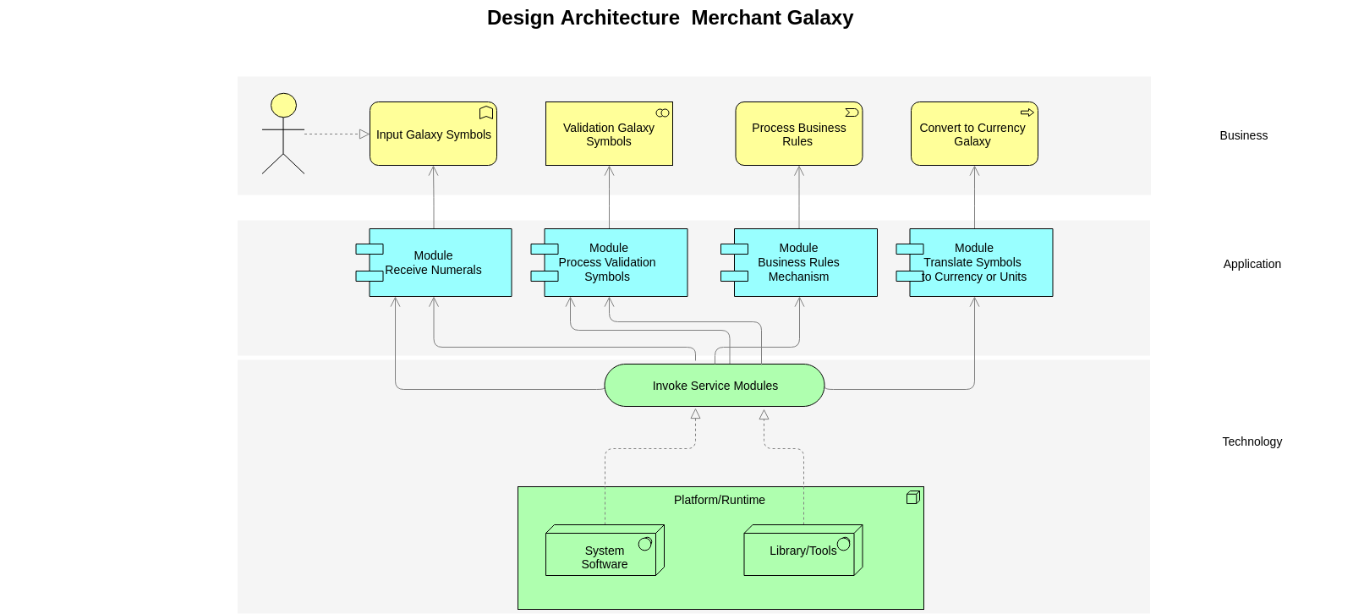

4. Approach to Implement the Architecture

For this implementation this architecture and think to improve some parts of this application I have decided to implement some commons pattern and structure in the project, follow some patterns:

* Service
* Convert
* Validation
* Helper
* Strategy
* Facade
* TDD – Test Domain Design
* DDD - Domain Drive Design

See the Class Diagram with the most of objects class that was created in the application

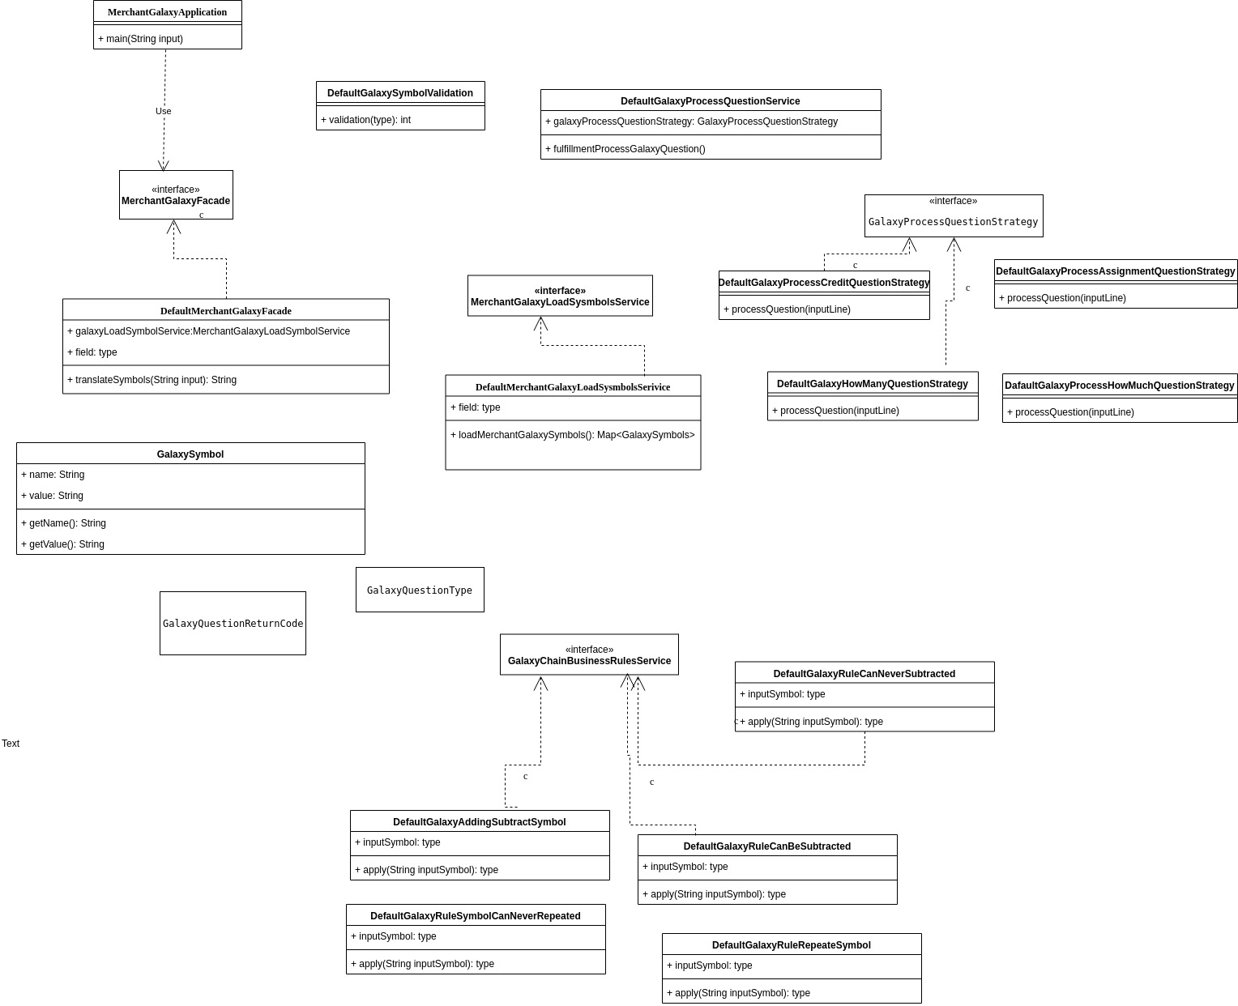

Ne pas supprimer ce saut de section >>>